## To Create a Group

There are two ways to group objects

1. Using the Grouping Toolbar:

* **Select All** - selects all of the objects on your plan
* **Group** - groups your selected objects together
* **Ungroup** - ungroups the grouped objects
* 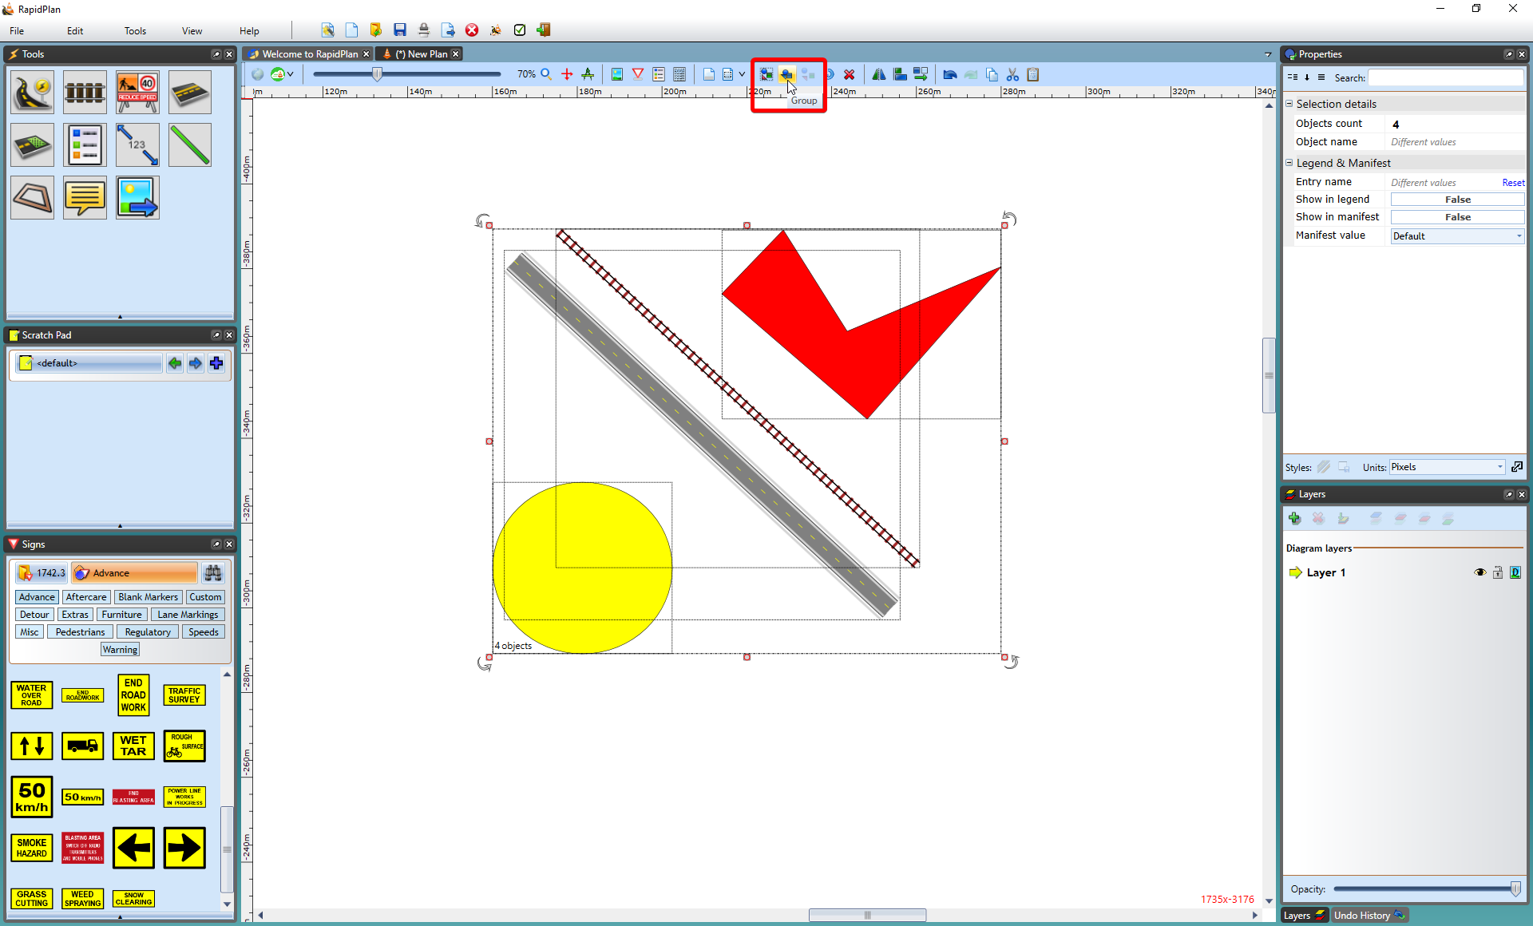
* Grouping_Objects_using_the_Toolbar
* **Note**: The individual bounding boxes and move handles are replaced by just one for the entire group.

1. Using your mouse or keyboard:

* Select the objects you want to group together (by pressing **SHIFT** and selecting each desired object individually or by dragging your mouse encompassing all of the desired objects).
* Right click and select **Group objects** from context menu
* Or hold **CTRL + G**.